**The Prince of Egypt (1998) – 3D Designs and Visual Style:**

Although The Prince of Egypt is primarily a 2D animated film, it innovatively incorporated 3D elements to create realistic environments and enhance the grandeur of its scenes.

**Environment and Architectural Design:**

Temples, palaces, and pyramids were designed using 3D models to add depth and scale to the visuals.

Virtual camera movement techniques were utilized to create wide panoramic shots, presenting ancient Egypt in an epic manner.

**Animation Techniques:**

The parting of the Red Sea scene was one of the earliest uses of 3D water simulation, resulting in stunningly realistic water movement.

While the characters were traditionally hand-drawn, they were occasionally integrated with 3D backgrounds for seamless transitions.

**Lighting and Atmosphere:**

Advanced lighting techniques were applied to blend 2D and 3D animation seamlessly, adding a magical ambiance to the scenes.

**Artistic Influence:**

The filmmakers drew inspiration from ancient Egyptian paintings, giving the film an authentic yet modern artistic style.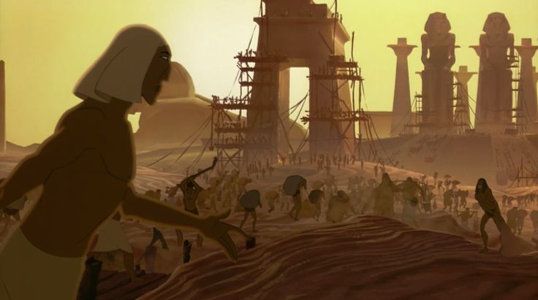

### **Assassin’s Creed Origins (2017) – 3D Designs and Visual Style**

Assassin’s Creed Origins is entirely built using 3D design and stands as one of the most accurate reconstructions of ancient Egypt, utilizing cutting-edge visual technologies.

**Environment and Architectural Design**

Ubisoft employed photogrammetry alongside historical references to meticulously recreate pyramids, temples, markets, and statues.

The open world was developed using procedural generation techniques, dynamically generating deserts and cities to mirror real-life landscapes.

**Character Design and Animation**

Motion capture was used to ensure natural character movements during combat and environmental interactions.

Rendering and rigging systems were enhanced to achieve precise facial expressions and body movements, boosting realism.

**Lighting and Visual Effects**

A dynamic day-night cycle and weather system were implemented, featuring dust and humidity effects that add a sense of realism.

Volumetric lighting and global illumination simulated sunlight reflections on buildings and water, creating stunning visual depth.

Ubisoft struck a balance between historical accuracy and artistic creativity, adding some fictional elements while maintaining the essence of ancient Egypt.

The Discovery Tour mode offers an interactive educational experience, allowing players to explore ancient Egypt’s landmarks in a fun and informative way.

**Key 3D Technologies Used**

**1. 3D Modeling**

Temples, pyramids, and Egyptian markets were sculpted using digital sculpting techniques in software like ZBrush and Autodesk Maya.

Displacement maps were applied to add intricate details to temple walls and hieroglyphic carvings.

**2. Real-time Lighting**

Global illumination was used to simulate realistic light reflections inside buildings and temples.

Volumetric lighting added fog effects and sunrays penetrating temple structures, enhancing the mysterious atmosphere.

**3. Texturing & Shading**

High-resolution 4K textures were created using Substance Painter, adding details like erosion and accumulated sand on surfaces.

Physically Based Rendering (PBR) ensured that materials like gold and stone reacted naturally to different lighting conditions.

**4. Animation & Physics**

Motion capture technology was implemented to make character movements highly realistic.

A wind and cloth simulation system was developed to make fabrics and sand interact naturally with the surrounding environment.

### 

#### 

#### 

#### **Moon Knight (2022)**

#### The Moon Knight series, produced by Marvel Studios, is one of the most notable modern productions that portrayed both ancient and contemporary Egypt using 3D design, visual effects (VFX), and virtual production techniques.

#### 

#### **Environment and Architectural Design**

#### The series utilized digital set extension techniques to expand real-life scenes and integrate 3D-rendered landmarks such as pyramids, temples, and ancient Egyptian relics.

#### 3D modeling was used to construct ancient Egyptian environments, including Khonshu’s palace and Pharaonic tombs.

#### Several scenes filmed in Cairo were enhanced with CGI to incorporate historical and cinematic elements for greater impact.

#### 3D projection mapping was applied to merge digital models with real footage, increasing the realism of the settings.

#### **Character Design and Animation**

#### The character Khonshu was entirely created using 3D animation and motion capture, allowing for precise facial expressions and body movements.

#### Mummies and mythological creatures were sculpted using ZBrush for digital detailing and animated in Blender, capturing intricate details of skin, bones, and torn fabrics.

#### Moon Knight’s suit was fully CGI in some scenes rather than a physical costume, enabling the addition of animated effects, such as magical fabric wrapping around his body.

#### Fight sequences utilized motion capture to ensure realistic and fluid movement.

#### Keyframing animation was employed for supernatural actions like summoning weapons and executing unnatural jumps.

#### **Lighting and Visual Effects**

#### Dynamic lighting was combined with magical light effects to create a mystical ambiance in scenes featuring gods or supernatural forces.

#### Volumetric lighting was used in temple and tomb sequences, adding a foggy and mysterious effect.

#### Moving sky elements, such as shifting star positions, were designed using CGI with astrophysics simulations, blending magic with realism.

#### Particle simulations were incorporated to create realistic moving sand, whether in desert scenes or during supernatural events.

#### Transformational scenes relied on fluid simulations and 3D morphing effects, such as when Marc Spector transforms into Moon Knight.

#### **Blending Realism with Fantasy**

#### The series adopts a dark fantasy style, merging real elements of ancient Egypt with Egyptian mythology.

#### Some temples and locations were inspired by real-world sites but were reimagined to fit the show’s mythological themes.

#### In the “journey to the afterlife” scene, procedural modeling was used to generate dynamic deserts and ever-changing dreamlike environments, reinforcing the supernatural atmosphere.

#### 

#### 